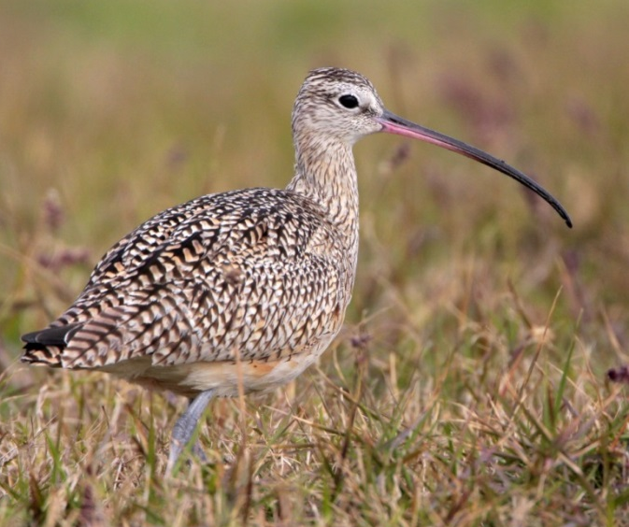
Long-billed Curlews on the Flathead Indian
Reservation/Mission Valley & Surrounding
Grasslands
From:
Add postage

Mail to:
Amy Cilimburg
Montana Audubon
1601 Tamarack St
Missoula, MT 59802

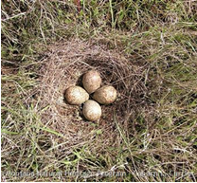

Long-billed Curlews on the Flathead Indian
Reservation/Mission Valley & Surrounding
Grasslands

Add postage

Amy Cilimburg
Montana Audubon
1601 Tamarack St
Missoula, MT 59802

Long-billed Curlew Sightings Report: - please print clearly
Name: _______ Email: ____________________ Phone: ________
Yes, I have a curlew(s) to report: ___ YES ___NO. Date(s) of sighting (if known): _________________________
Location:_________________________________________________________________________________________________________________________________________________________________________________________________ (we’d love to have a marked map or GPS coordinates).

Any additional information? (Number of birds, any nests found, have they raised young, timing of activity, interesting things you noticed, etc.):

___ ___ ___

Would you be willing to let someone survey curlews on your property? ___ YES ___NO thanks.
Questions? Email amy@mtaudubon.org. Photos of the curlews and the location you found them are most welcome.

Long-billed Curlew Sightings Report: - please print clearly
Name: _______ Email: ____________________ Phone: ________
Yes, I have a curlew(s) to report: ___ YES ___NO. Date(s) of sighting (if known): _________________________
Location:_________________________________________________________________________________________________________________________________________________________________________________________________ (we’d love to have a marked map or GPS coordinates).

Any additional information? (Number of birds, any nests found, have they raised young, timing of activity, interesting things you noticed, etc.):

___ ___ ___

Would you be willing to let someone survey curlews on your property? ___ YES ___NO thanks.
Questions? Email amy@mtaudubon.org. Photos of the curlews and the location you found them are most welcome.

