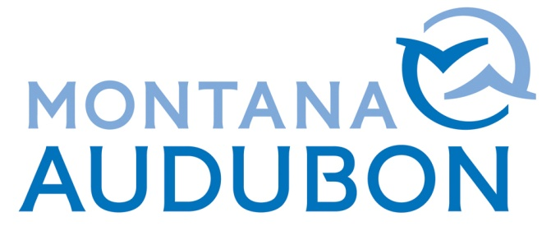
2019 Audubon Wildlife Fund of Montana - Grant Proposal Form

Instruction: Grants are limited to 2 pages and must be emailed (preferred)/post marked by Friday, December 14, 2018. Submit to Norane Freistadt: norane@mtaudubon.org or via post to: Montana Audubon, Attn. Norane Freistadt, Box 595, Helena, MT 59624

Name: ________________________________ Phone: _____________________________

School/ Organizational Affiliation (if applicable):______________________________________

Address: _____________________________________________________________________

City: ________________________ State: _________ Zip: _________ Date: ________________

E-mail: _________________________________ Faculty Sponsor*:__________________
*Required for students submitting proposals

- PROJECT TITLE:

- PURPOSE of the Proposed Project:

- Methods to be Employed (if applicable):

- Brief Project Description:

- Products of the Proposed Project:

- BRIEF DESCRIPTION OF Schedule for Completion of the Project:

- Budget

Project Expenses:
Travel: $_________
Supplies: $_________
Equipment: $_________
Printing: $_________
Other (please explain): $_________

TOTAL PROJECT BUDGET: $_________

Project Income:
Amount Requested from Audubon Wildlife Fund: $_________
Amount Requested from other Funding Sources: $_________

If this project is affiliated with a nonprofit organization, what is the
organization’s budget for the current fiscal year? $_________

Are All Other Funding Sources Secured for this Project? Yes / No (select one)*
* If all funding sources are not secured, when will you know if the project is a “go”? (please explain):

- HAVE YOU OR YOUR ORGANIZATION RECEIVED AN AUDUBON WILDLIFE FUND GRANT BEFORE? Yes / No (select one) IF SO, PLEASE GIVE A SHORT DESCRIPTION OF THE GRANT PROJECT AND IF THE PROJECT WAS COMPLETED:

- WILL MONTANA AUDUBON BE ACKNOWLEGED FOR THIS GRANT? IF SO, HOW:

- REMINDER: bRIEF GRANT REPORTS EXPLAINING PROJECT STATUS AND USE OF FUNDS IS DUE TO mONTANA aUDUBON BY oCTOBER 1, 2019.

