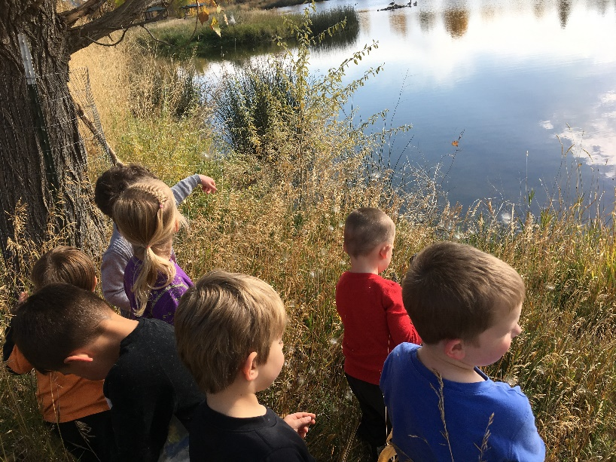

Fledglings Preschool
7026 S. Billings Blvd. Billings, MT 59102
294-5099

Philosophy
We believe that young children learn best through play. We work to foster a trusting relationship between our students and our teachers. We think that there is great value in allowing children to take risks and to explore our natural world with their whole being.

Registration and Tuition
Registration begins March 1, 2019. To fully register your child you must pay the first month’s tuition, be a member of the Montana Audubon Center and fill out our application form. Registration is on a first come basis.
Your child must be FULLY potty trained by the start of school in the fall. If your child has repeated accidents at school they may be asked to leave school.
Tuition is due on the 5th of each month. You may pay by cash, credit/debit card or check. We strongly recommend setting up a monthly bill pay through your bank.

There’s No Such Thing as Bad Weather
Our goal is to be outside for 80% of our day. This means that your child must come to school everyday prepared to spend the majority of the day outside. We also spend time away from our school building, your child is expected to help carry their gear and sometimes their lunch. Please provide your child with a backpack large enough to hold their lunch and a change of clothes.
When the wind chill is below zero we minimize our outdoor time.
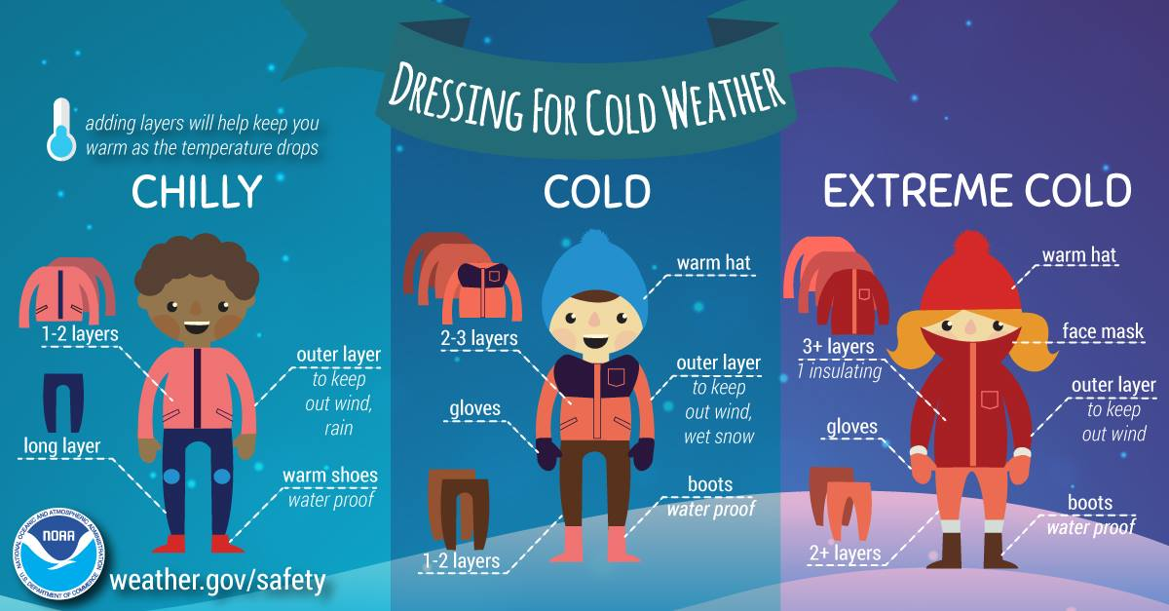

Gear and brands we love:
Oakiwear rain pants and rain suits www.oaki.com
Boggs boots www.bogsfootwear.com
Name Bubbles clothing labels www.namebubbles.com
Close-toe sandals
Several pairs of waterproof gloves
Several pairs of lightweight gloves
We believe that your child is capable of self -regulating their temperature. Their clothing choices during our school day may not always agree with what adults think they should wear. We practice good judgement and require children to alter their choices when exposure is deemed unsafe.

Snacks and Meals
Energizing snacks are provided for all classes, in turn by the school and parents. We often involve our students in the preparation of snacks through harvesting and baking. We will attempt to make our snacks allergy friendly to accommodate students in our classes.
Families are required to send a packed lunch daily for all AM classes. Lunches are stored in a refrigerator unless we are hiking away from the building for lunch.

Behavior and Conflict Resolution
At Fledglings Preschool it is our goal to help our students make ethical decisions rather than impose ambiguous rules. As children work through this process there are often conflicts. We encourage our students to problem solve on their own using the following three steps: 1. Use your words 2. Walk away from the situation 3. Ask an adult for help. If a conflict gets out of control or your child needs some time to reset they will be asked to take a time out with our cool down basket.

Illness
Please keep your child home from school if they have any sort of illness that is contagious or would prevent them from fully participating in our school day. Your child is required to stay home from school for 24 hours after they have had a fever or diarrhea

Celebrations
We value your child and enjoy being a part of their celebrations. We love to celebrate birthdays and half birthdays, you are welcome to send a treat.

Family Days
Families are invited each month to join us for lunch or a more extended activity. This is a wonderful way for parents to get to know other students, other parents and to observe how your child interacts with others at school.

In Case of Emergency
Children will be closely supervised during their time at preschool, however
under the closest supervision accidents still may occur. In each case, parents will be notified of any accidents and the circumstances with which it occurred. If the accident is minor, the staff will handle it and either call to inform you or report it when your child is picked up. Our first action will always be to make sure you child and the other children in class are safe and cared for.

All staff are certified in CPR and first aid.
Please note that climbing, digging, running, balancing and many of the other adventurous things your child will be doing in Fledglings Preschool will result in minor abrasions and bruises. We believe in the value of letting children take risks. Risk taking helps children make good decisions, builds confidence, and solidifies learning.

Pick Up and Drop Off
Pick up and drop off occurs in our main parking lot. Please be on time for pick up and drop off so that we can be off to our adventures as soon as possible. Please exit your vehicle and walk your child to and from their teacher to insure their safety. Pick up is a great time to check in with your child’s teacher or have them check in with you.

